

**2023**



**PLEASANT TOUR**

|  |  |  |
| --- | --- | --- |
| Supervisor | Sir Mansoor Ahmed | |
| Batch | **PR2-202209C** | |
| Group | **B** | |
| Serial No. | **Enrollment Number** | **Student’s Name** |
| 1. | Student1413687 | Ariba Asif |
| 2. | Student1413190 | Areesha Manzoor Khan |
|  |  |  |

**Table of Contents**

Certificate of Completion 4

Acknowledgement 5

Project Synopsis 6

Problems Statement: 7

Functional Requirement 7

Hardware and Software Requirement 8

Website Features 9

FLOW CHART 10

USER’S GUIDE 11

HOME PAGE: 11

15

CONTACT US: 16

17

ABOUT US: 18

CATEGORIES OF PLEASANT TOUR 20

PAKISTAN: 20

SINGAPORE: 21

UAE: 22

MALDIVES: 23

DESTINATION OF PLEASANT TOUR: 24

BEACHES: 24

HILL STATION & FORT PLACE: 25

DEVELOPER’S GUIDE: 26

NAVBAR: 26

SLIDER: 27

CARDS: 28

FOOTER: 28

# **Certificate of Completion**

This is to certify that Ariba Asif, Areesha Manzoor Khan, have successfully completed their ACCP Prime 2.0

Semester I E-Project.

Submitted to: **Aptech Computer Education**

On

**February 10th, 2023**

# **Acknowledgement**

First of all we would like to thank **Almighty Allah** for giving us strength and ability to complete this project.

And then, we would like to express my special thanks of gratitude to our teacher **Sir Mansoor Ahmed** who guided us on the project ***Pleasant Tour.*** Which also helped us in doing a lot of new learning and we came to know about so many new things we are really thankful to him.

We are highly thankful to **Sir Mansoor Ahmed** for his guidance and constant supervision as well as for his support in completing the project.

Lastly, we would also like to thank our parents and friends who helped us a lot in finalizing this project within the limited time frame. We also express our sincere gratitude to I-Project team from Aptech Head Office, for their valuable guidance and support for the completion of this project. We earnestly hope that this project will provide all the necessary information required by the user to fulfill his/her inspiration. However, suggestion and Feedbacks for improvements will be thankfully welcomed & acknowledged*.*

# **Project Synopsis**

**Pleasant Tours** is into selling various tour products.

We have predefined tours with itineraries. We advertise by distributing the pamphlets, advertising on television and so on. Due to rapid development in internet field, we decide to launch a website where people will get all the information about the various tour products available with them easily.

'Adventure' means something different to all of us, here at **Pleasant Tours** we simply define an adventure as a collection of experiences that are fulfilling to the soul because an adventure is whatever you want it to be - whether that be a beach tour or an hills base camp trek.

# **Problems Statement:**

Pleasant Tours is into selling various tour products. They have predefined tours with

Itineraries. The company advertises by distributing the pamphlets, advertising on

Television and so on. Due to rapid development in internet field, the company

Decides to launch a website where people will get all the information about the

Various tour products available with them easily.

# **Functional Requirement**

# The Web site is to be created based on the following requirements.

1) The Home Page should be created having sections, graphics and with a

Suitable logo

2) The site should display a menu which will contain the options for brief

Introduction about the various products available, location of the shop and

Any other information if required.

3) The information should be categorized according to different type of products

Like if a User wants to see only ‘Beach Tours’ then he click on a

Link/button/menu etc. and he will see different type of Beach Tours. Similarly

For ‘Hill Stations’, ‘Forts/Palaces’ and other products

4) When a user selects any product type, a list of products for that product type

Will be displayed.

5) Itinerary of individual tour products should be displayed on the Web Page

Along with the title but detailed itinerary should be stored in Individual Word

Documents which can be downloaded or viewed by the User who wishes to

See the same.

6) Price List for all tours should be available for download.

7) There should be a “Contact Us” page which will have the Address of the

Company which is as follows and the mail address which when clicked will

Invoke the local mail client from where they can send an email.

# **Hardware and Software Requirement**

Hardware

* A minimum computer system that will help you access all the tools in the

Courses is a Pentium 166 or better

* 64 Megabytes of RAM or better

**Software**

* Notepad/HTML editor
* Dreamweaver
* IE 5.0/ Netscape 6.0

# **Website Features**

Our site displays a menu which contain the options for brief introduction about the various tour products available, location of the product and many other information if needed.

The information categorized according to different type of products like if a User wants to see ‘Beach Tours’ then he clicks on a menu and he will see different type of Beach Tours. Similarly, for ‘Hill Stations’, ‘Forts/Palaces’ and other products and also if user want to see the selected country tours like if user want to see ‘Pakistan Tours’ he clicks on menu select Pakistan and enjoy and book where he wants to go for tour.

When a user selects any tour product type, a list of tour products for that tour product type will be displayed.

Itinerary of individual tour products should be displayed on the Web Page but detailed itinerary stored in Individual Word documents which can be downloaded or viewed by the User who wishes to see the same.

Price List for all tours should be available for download.

We have a “Contact Us” page which have the Address of the Company and the mail address which when clicked will invoke the local mail client from where they can send an email.

# **FLOW CHART**

# **USER’S GUIDE**

## HOME PAGE:

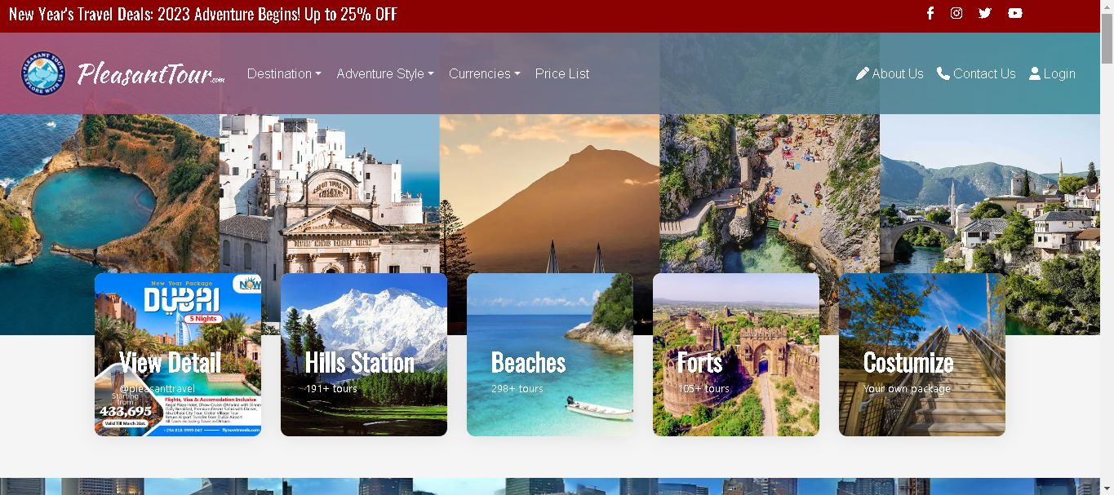

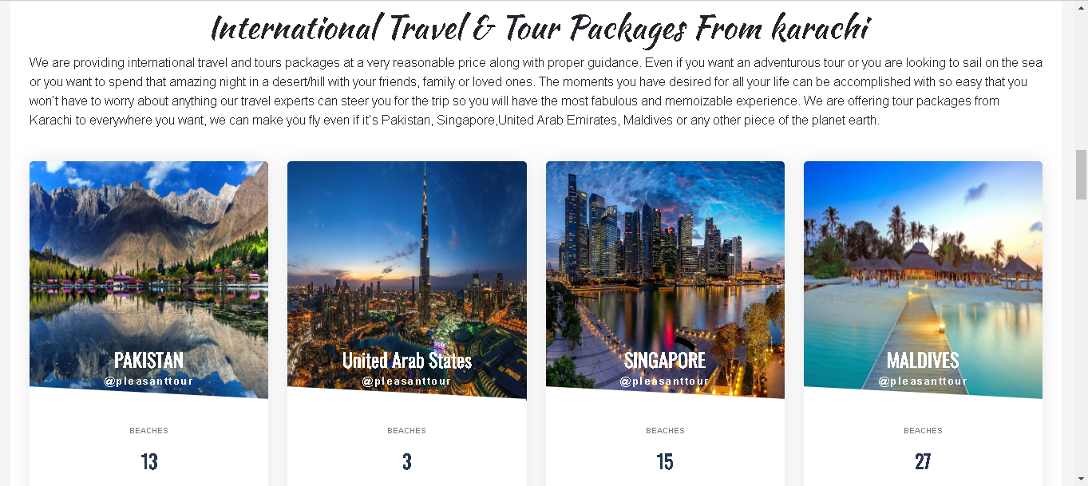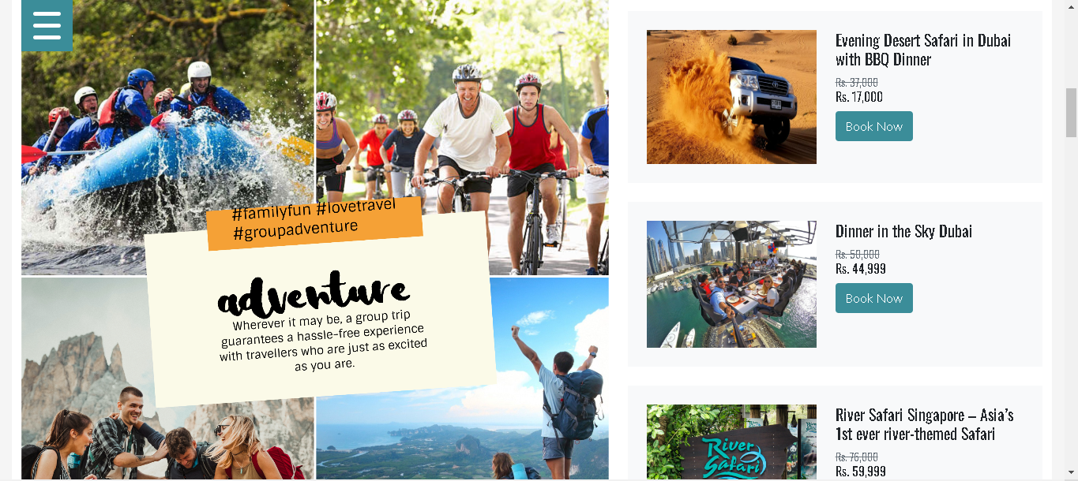

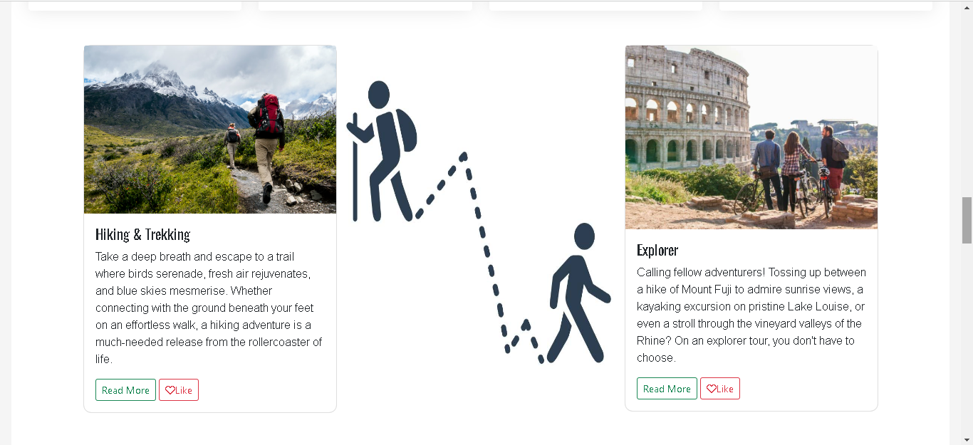

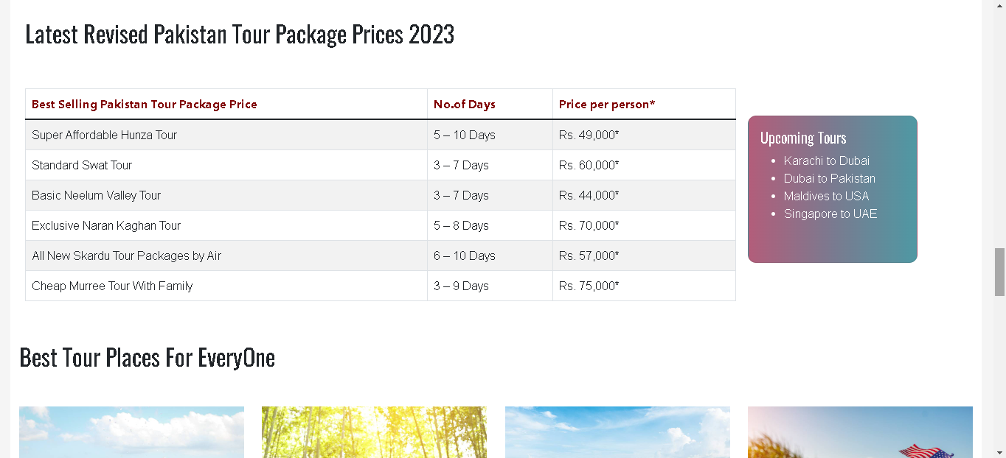

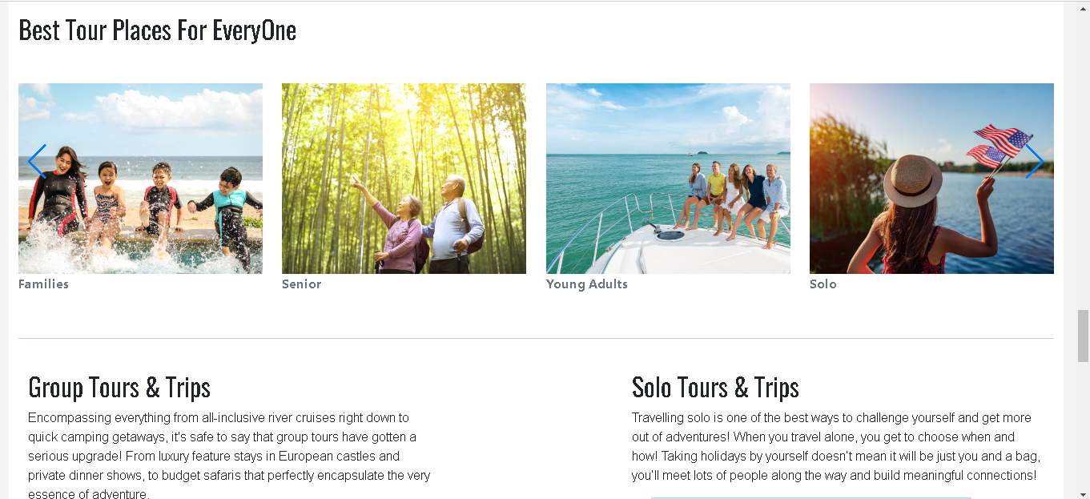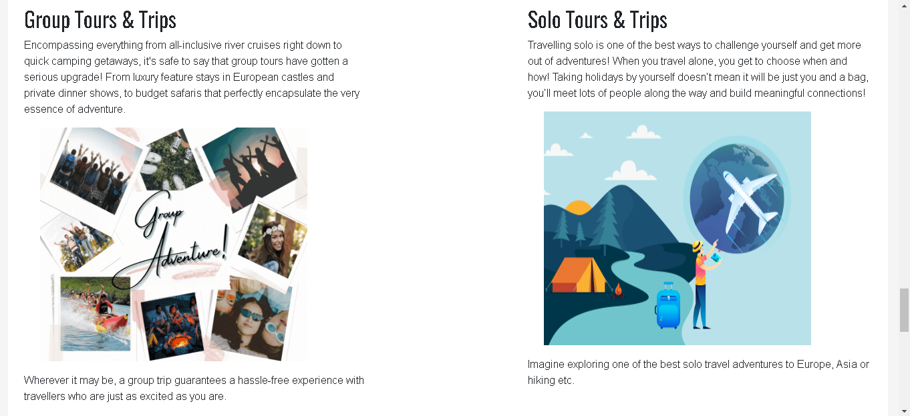

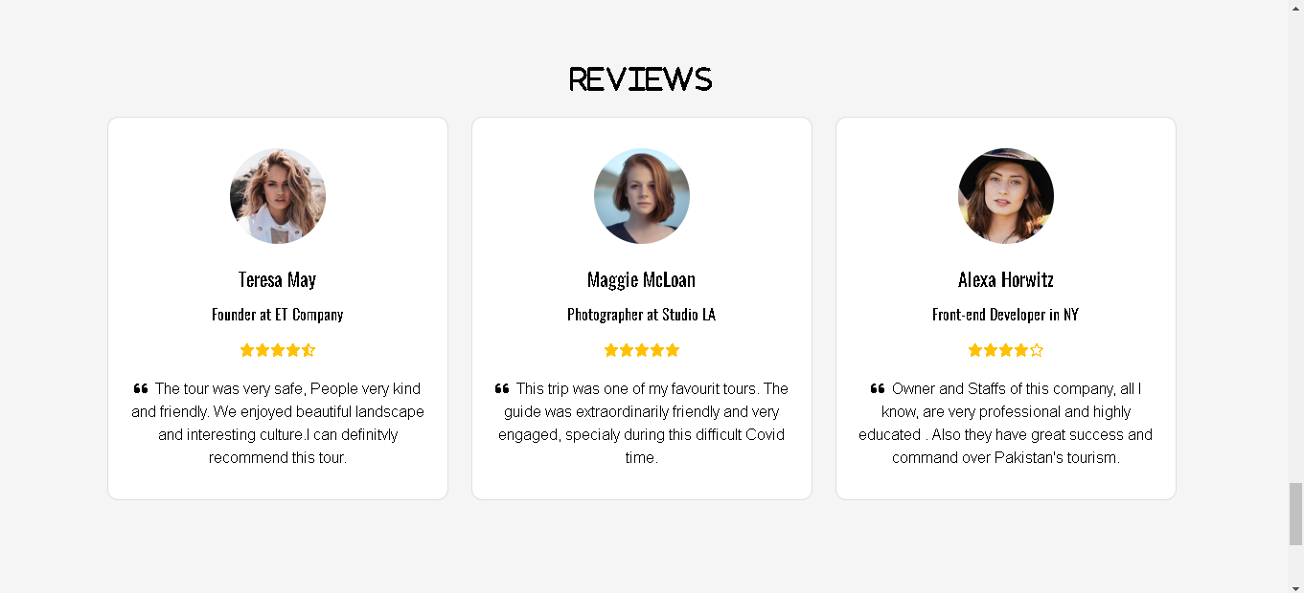

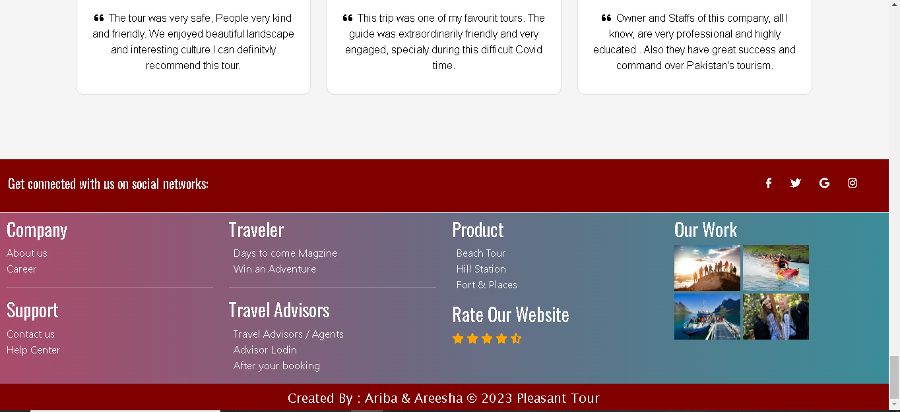

## CONTACT US:

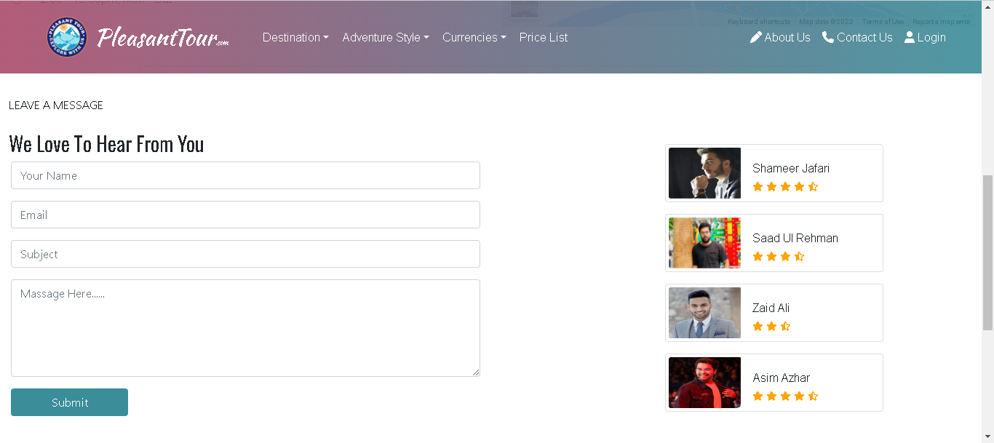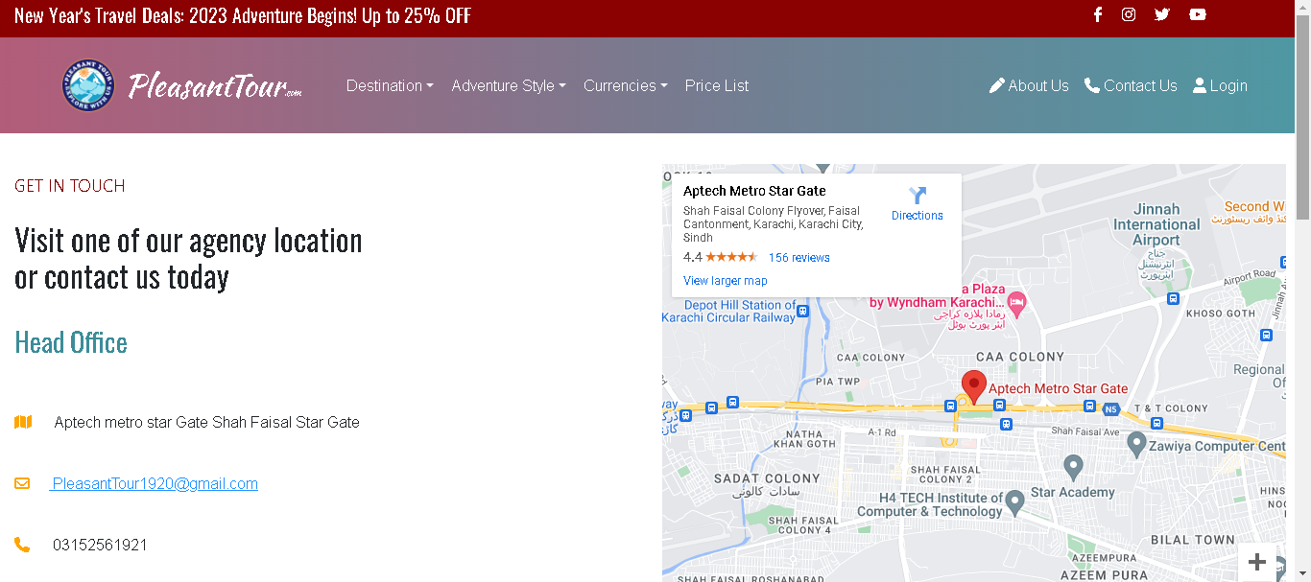

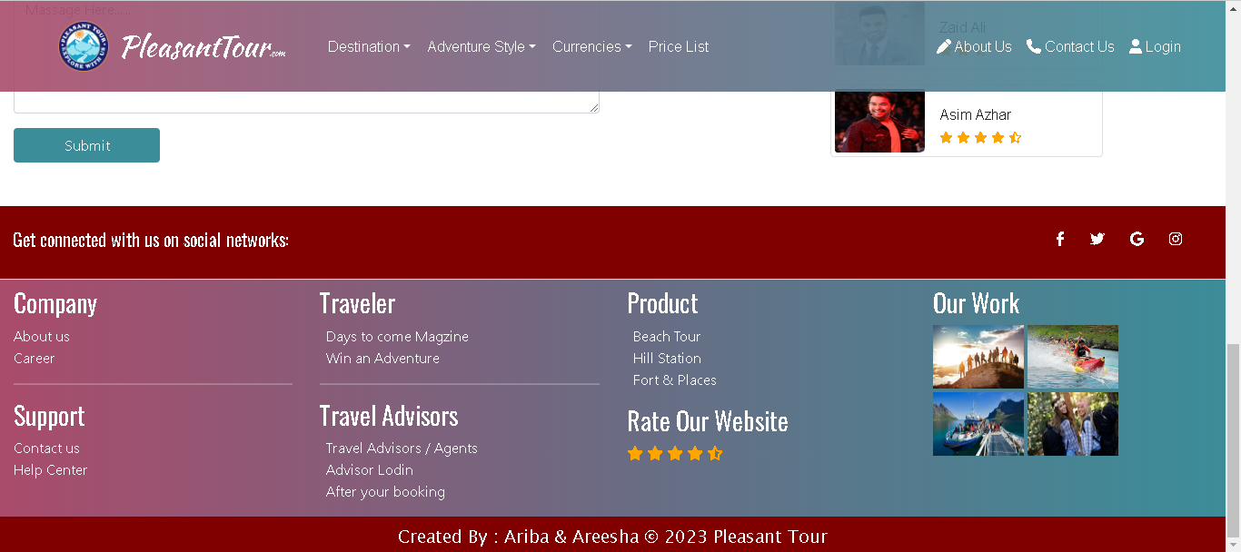

## ABOUT US:

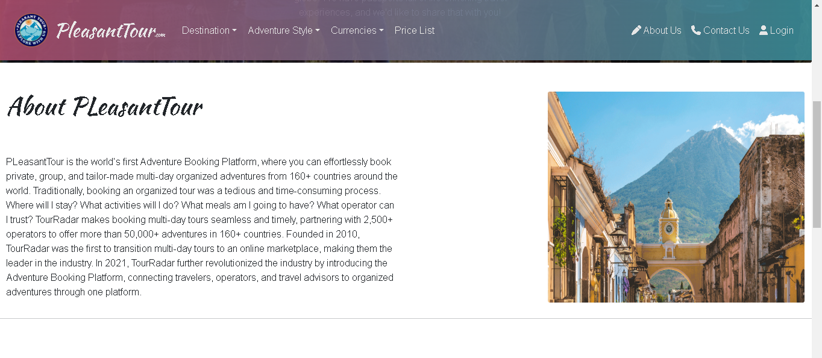

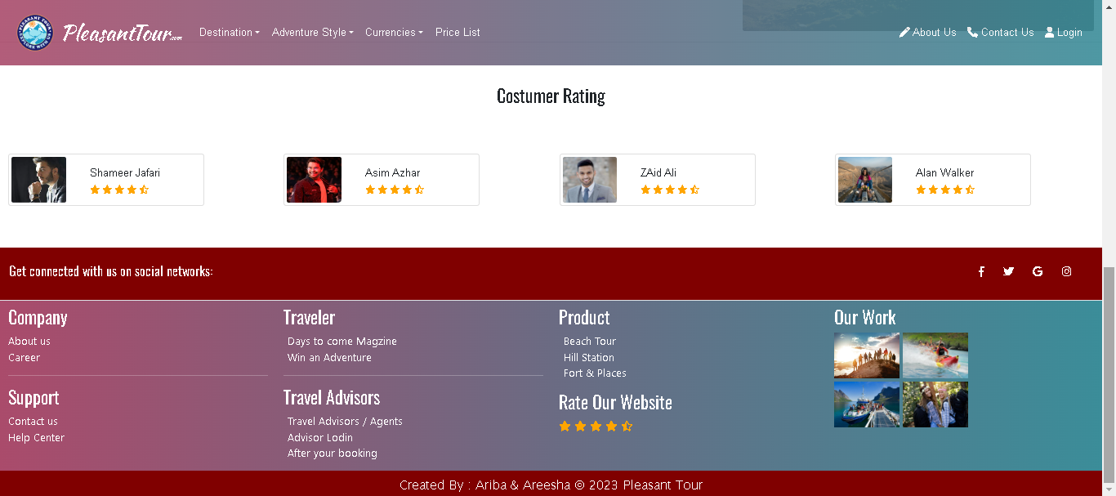

# **CATEGORIES OF PLEASANT TOUR**

## PAKISTAN:

## SINGAPORE:

## UAE:

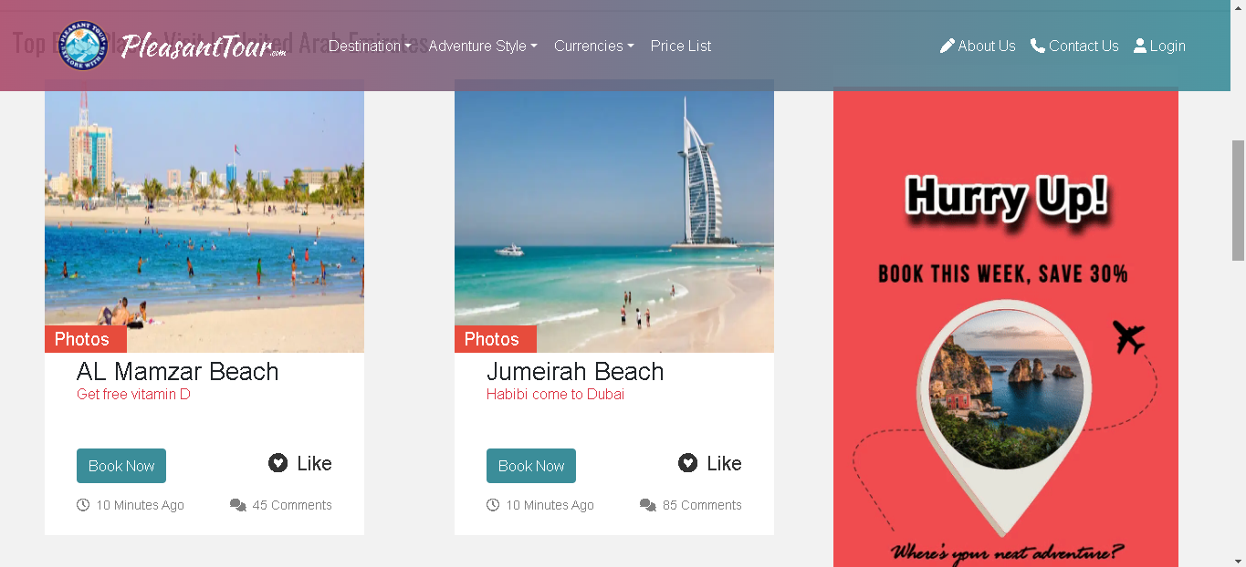

## MALDIVES:

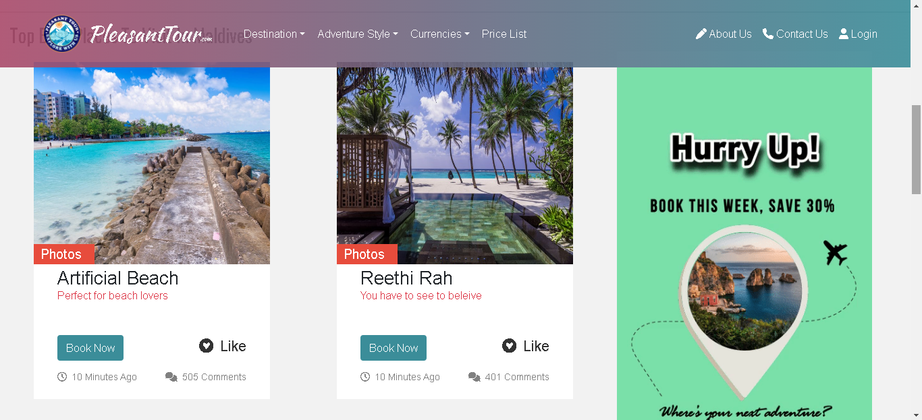

# **DESTINATION OF PLEASANT TOUR:**

## BEACHES:

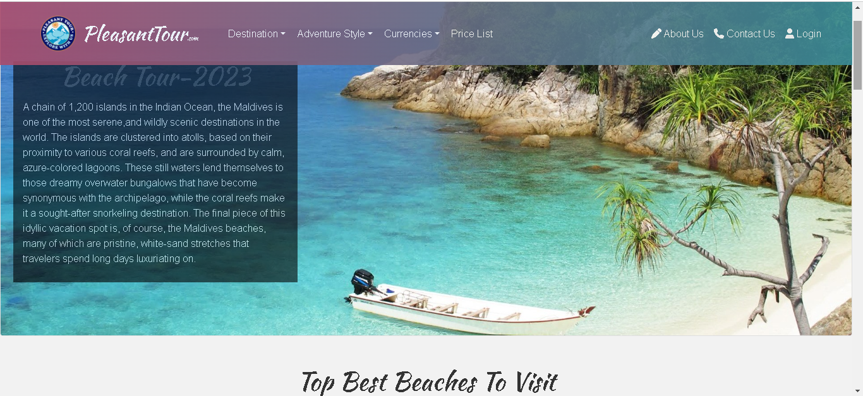

## HILL STATION & FORT PLACE:

# **ITERNARARY:**

# **DEVELOPER’S GUIDE:**

## NAVBAR:

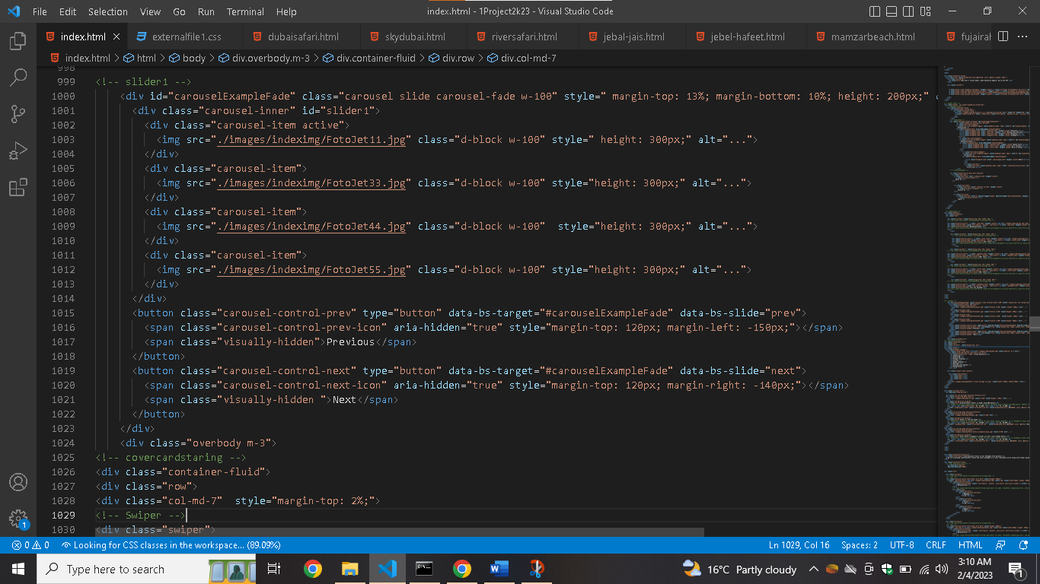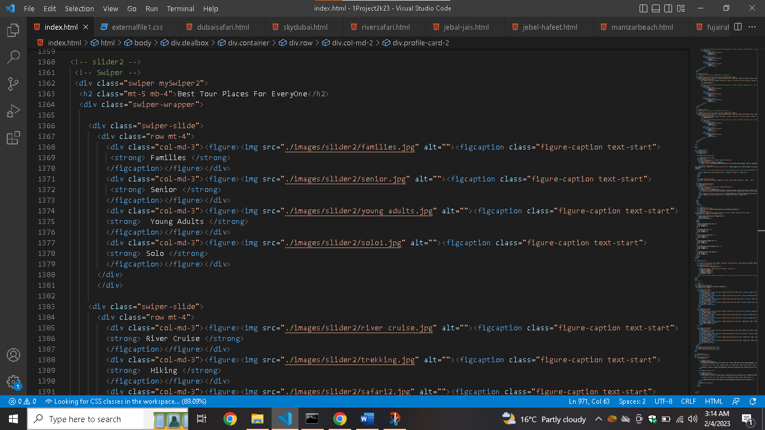SLIDER:

## CARDS:

## 

## FOOTER:

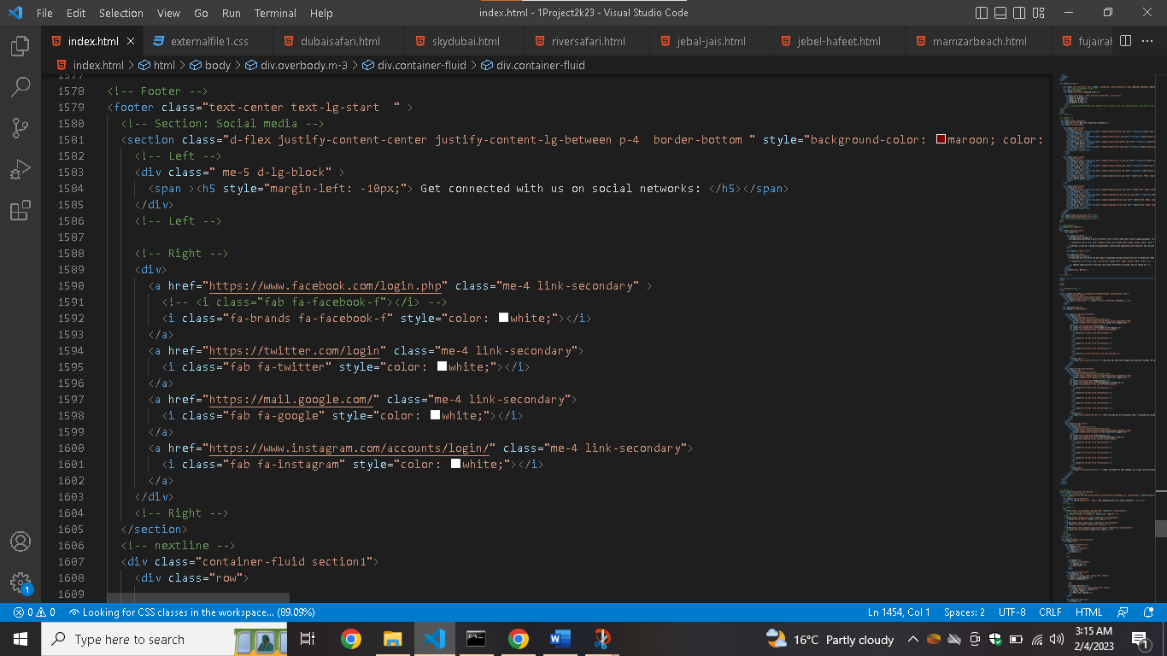

|  |  |  |  |  |
| --- | --- | --- | --- | --- |
| Project Ref. No. | | Project Title | Date of Preparation of Activity Plan | |
| S.No. | Ta | **PLEASANT TOUR** | Actual Days | Status |
| 1 | Analysis | 1 | OK |
| 2 | Design | 6 | OK |
| 3 | Development | 7 | OK |
| 4 | Testing | 1 | OK |
| 5 | Documentation | 2 | OK |

# **Task Sheet**